**LAKSHMI SWAMINATHAN**

**Task 1.A (using ARP request). On host M, construct an ARP request packet to map B’s IP address to M’s MAC address. Send the packet to A and check whether the attack is successful or not.**

**spoof_arp_request.py:** Below code is for spoofing the ARP cache of A with B’s IP address mapped to M’s MAC address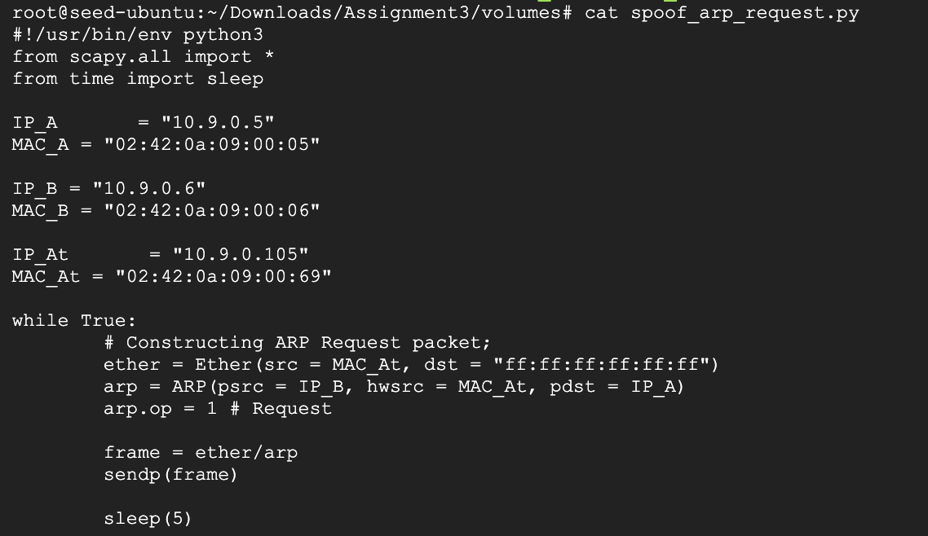

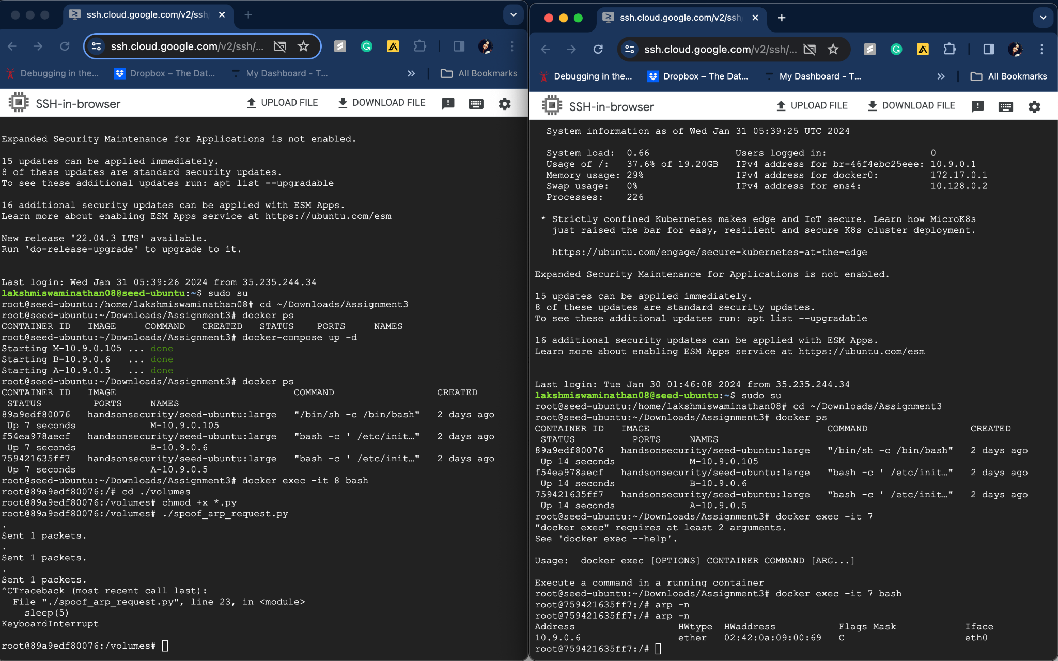

The above is the result of execution of spoof_arp_request.py, host A’s ARP cache has B’s IP address mapped to M’s Mac address.

**Task 1.B (using ARP reply). On host M, construct an ARP reply packet to map B’s IP address to M’s MAC address. Send the packet to A and check whether the attack is successful or not.**

Below is the code for ARP reply from host M to host A to spoof the ARP cache of host A by mapping host B’s IP address to M’s Mac address

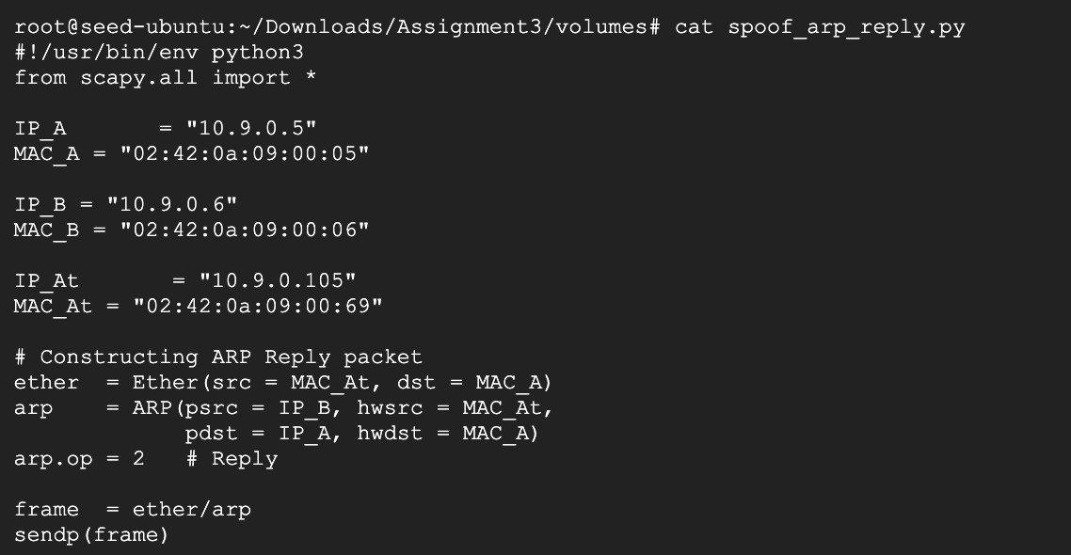

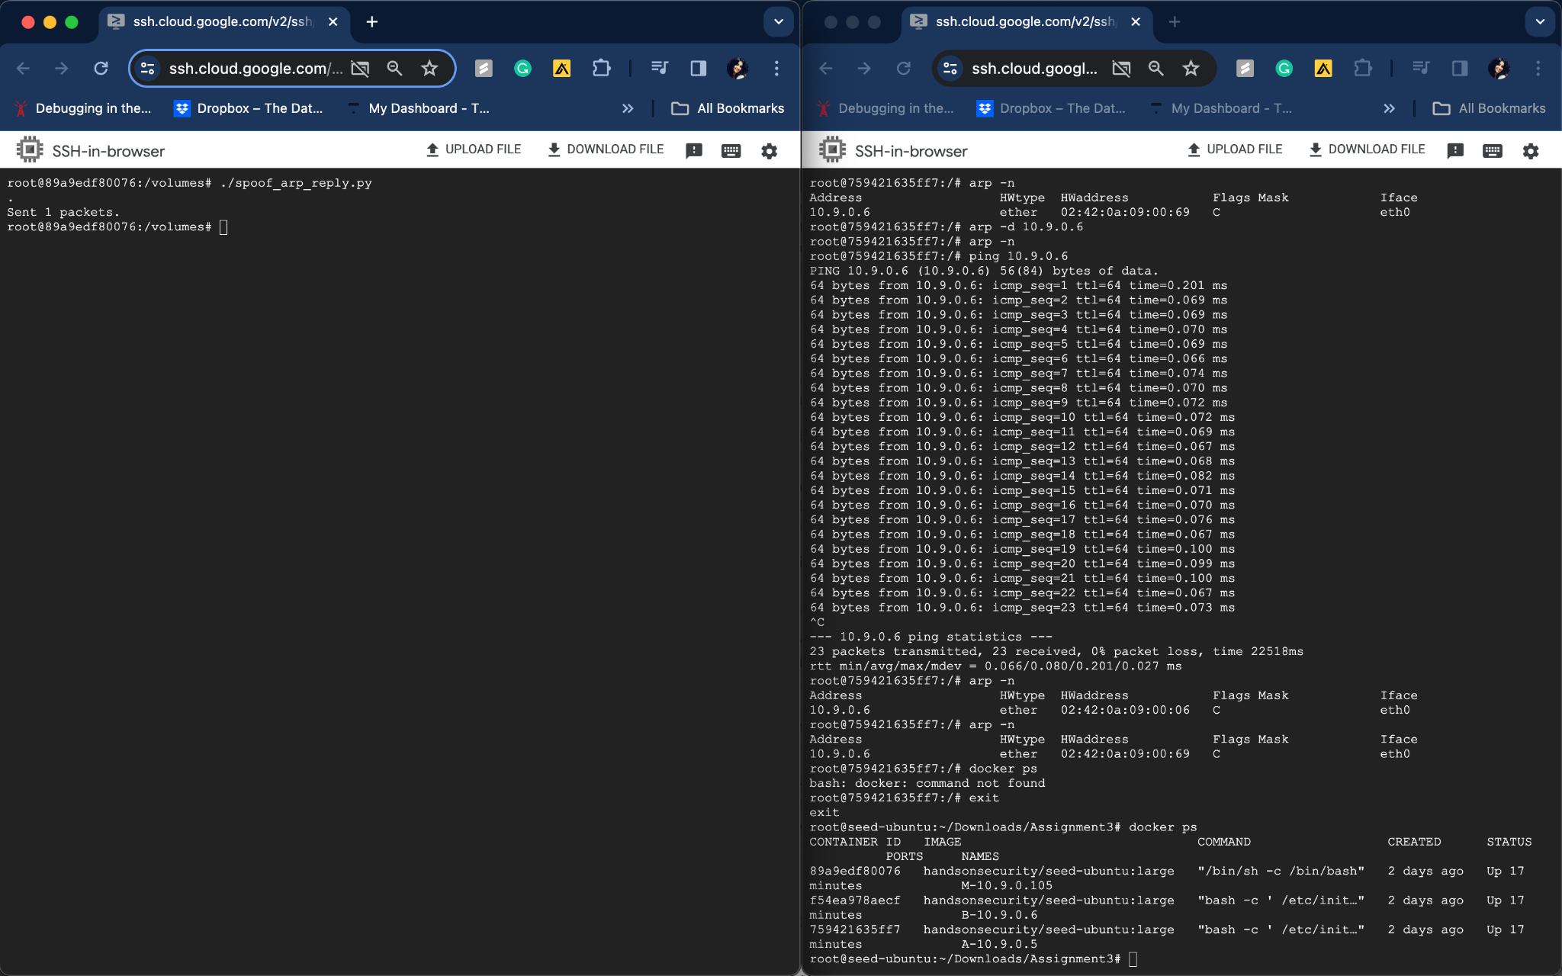

**Above is the result of execution of spoofing ARP cache by ARP reply from host M to host A when host A already has B’s IP address in ARP cache. :** The host A’s ARP cache is spoofed with host B’s IP address mapped to host M’s MAC address.

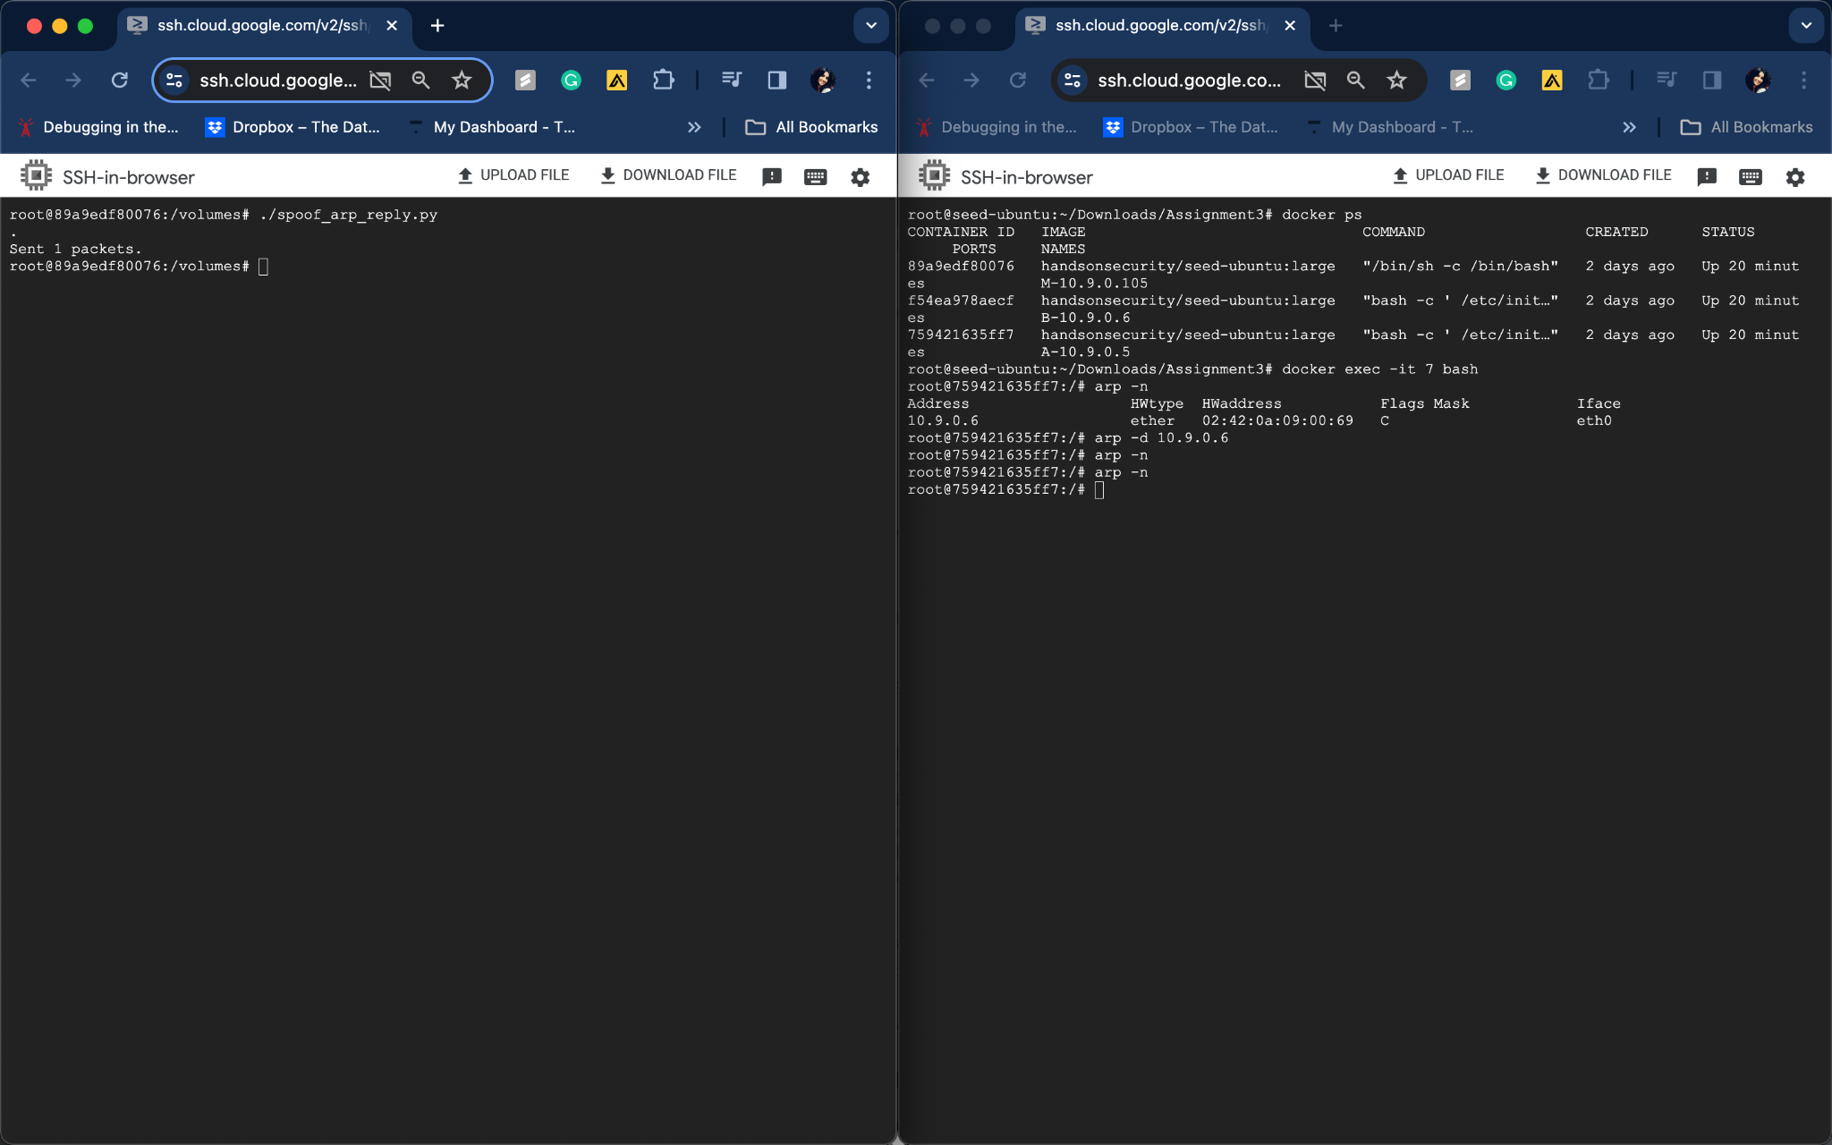

**Above is the result of execution of spoofing ARP cache by ARP reply from host M to host A when host A doesn’t have host B’s IP address in ARP cache(host B’s IP address is removed from host A’s cache before executing the spoof_arp_reply.py code from host M) :** ARP cache spoofing didn’t happen for host A under this scenario.

**Task 1.C (using ARP gratuitous message). On host M, construct an ARP gratuitous packet, and use it to map B’s IP address to M’s MAC address**

Below is the code for ARP cache spoofing using ARP gratuitous message from host M to host A attempting to spoof host A’s ARP cache with host B’s IP address mapped to host M’s MAC address

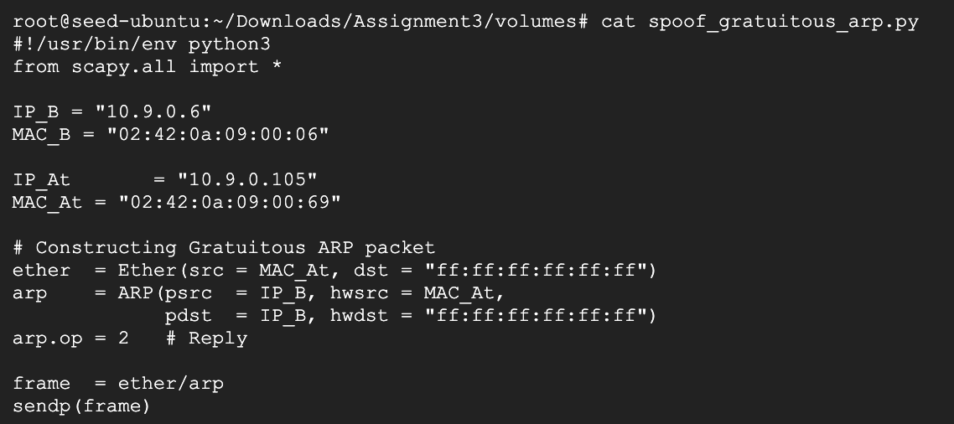

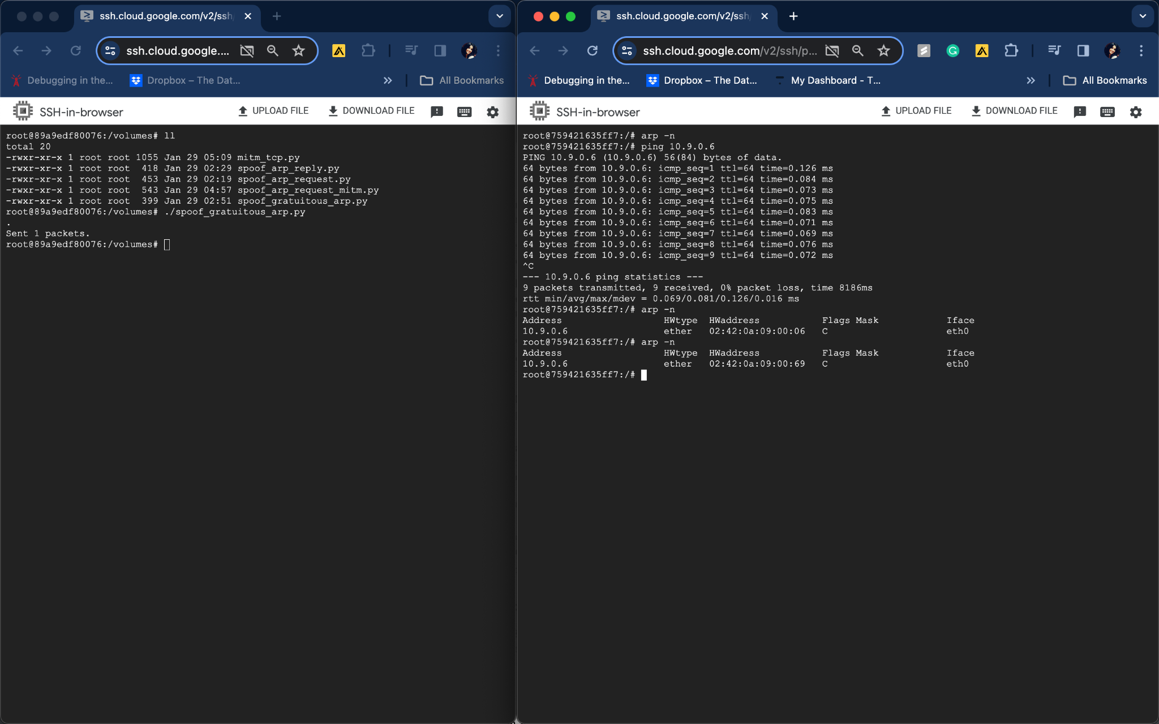

**Above is the result of execution of spoofing ARP cache by ARP gratuitous message from host M when host A already has host B’s IP address in ARP cache. :** The host A’s ARP cache is spoofed with host B’s IP address mapped to host M’s MAC address.

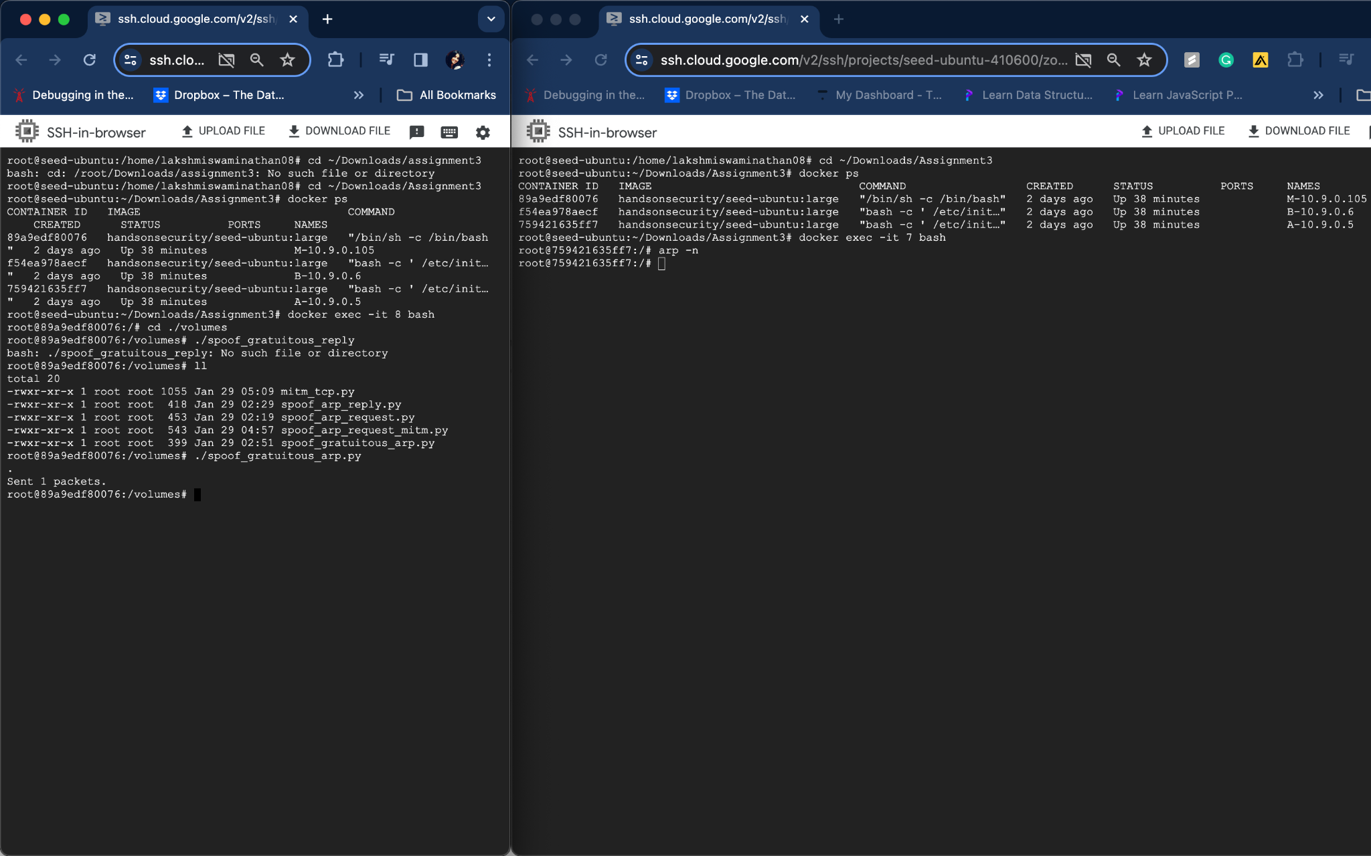

**Above is the result of execution of spoofing ARP cache by ARP gratuitous message from host M when host A doesn’t have host B’s IP address in ARP cache. :** The host A’s ARP cache is not spoofed under this scenario.

**Task 2: MITM Attack on Telnet using ARP Cache Poisoning**

**Step 1: Launch the ARP cache poisoning attack:** Spoofing host A’s ARP cache with host B’s IP address mapped to host M’s MAC address and host B’s ARP cache with host A’s IP address mapped to host M’s Mac address.

**Code:**

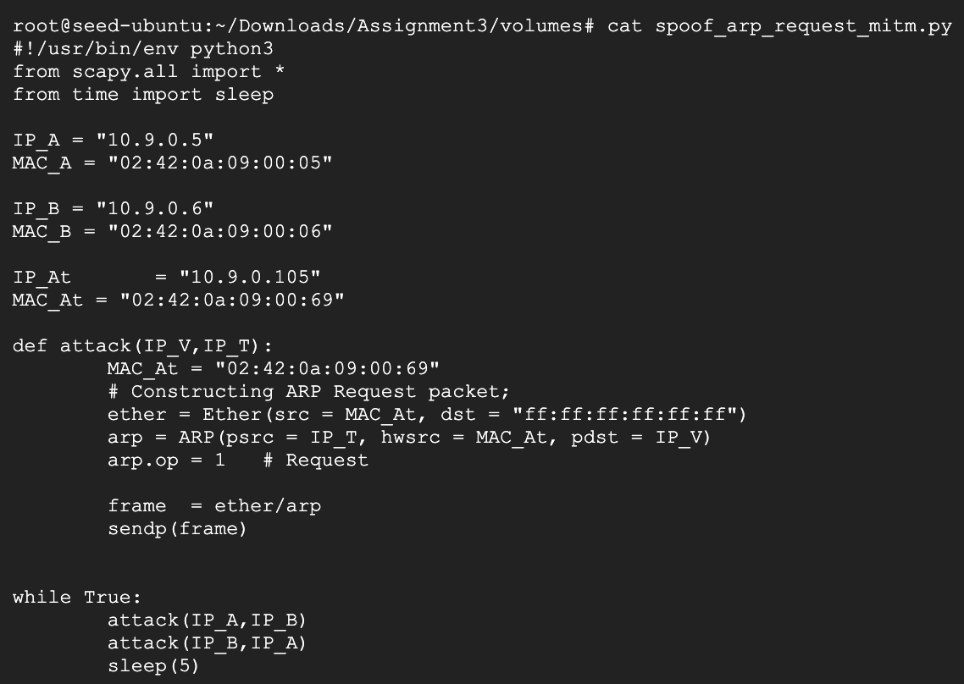

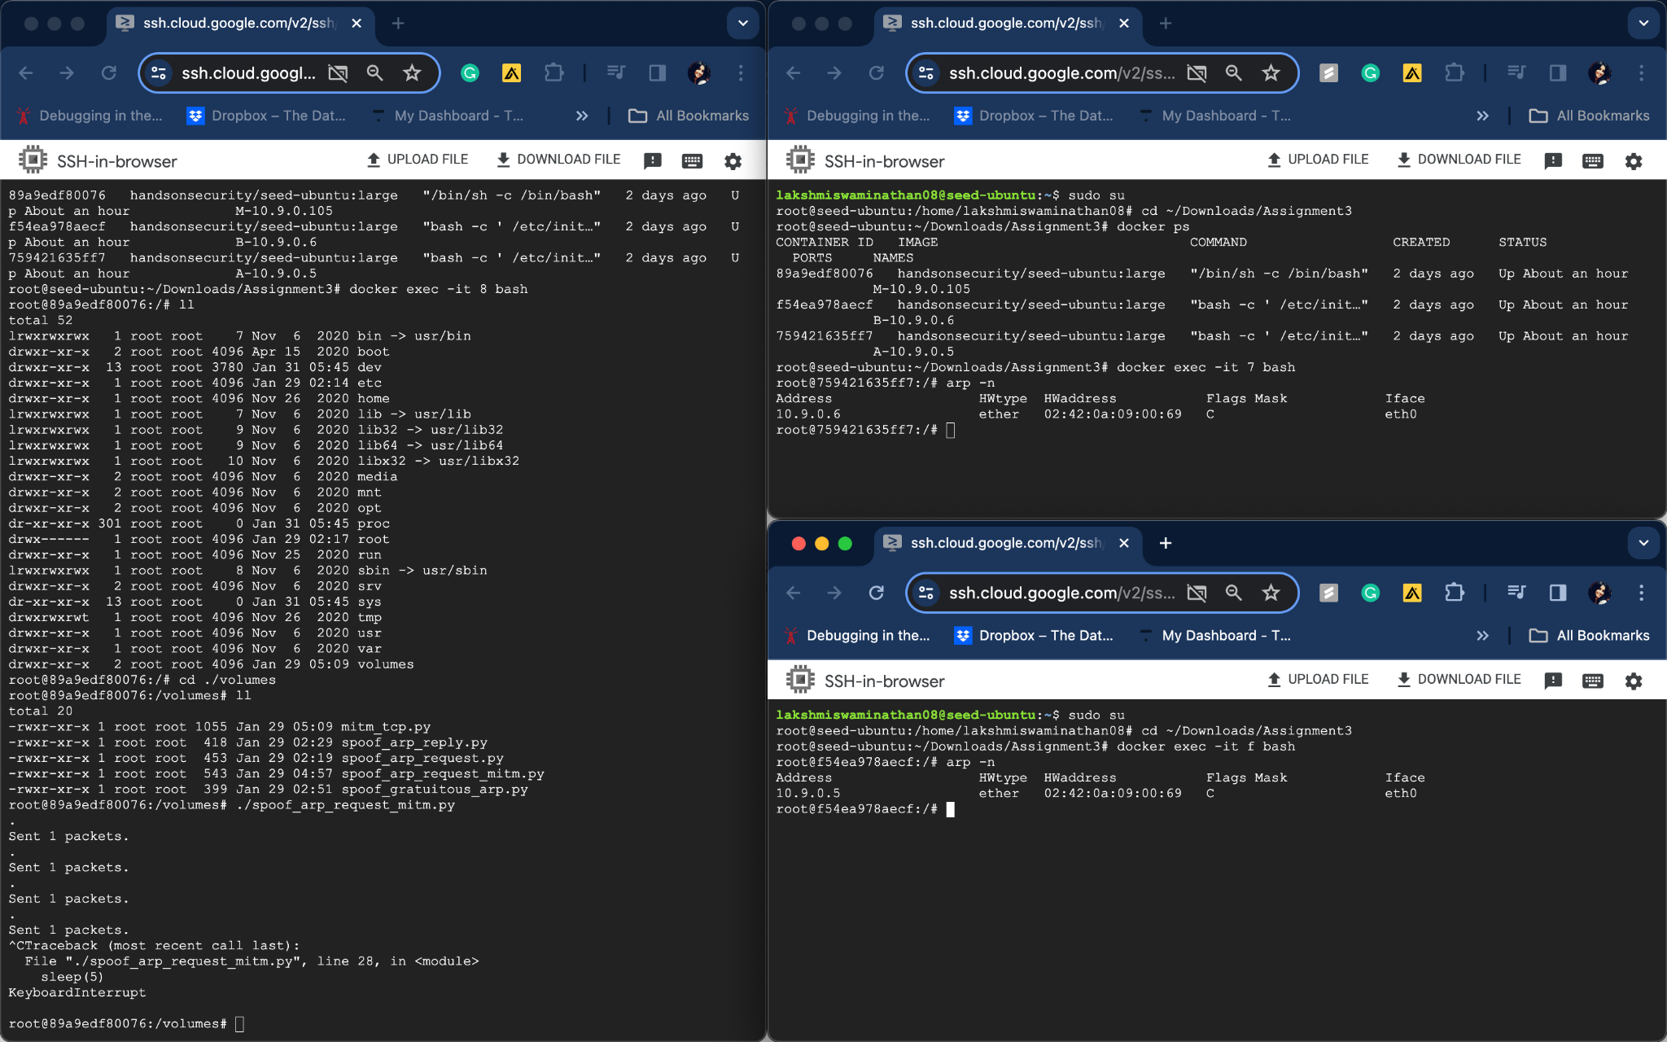

Above is the result of the execution of host M(attacker) ARP cache poisoning host A with host B’s IP address mapped to host M’s MAC address and host A’s IP address mapped to host M’s MAC address in host B.

**Step 2:** **Pinging host A to B and host B to A when the ARP cache is poisoned for host A and host B with IP forwarding turned off(sysctl net.ipv4.ip_forward=0) in host M.**

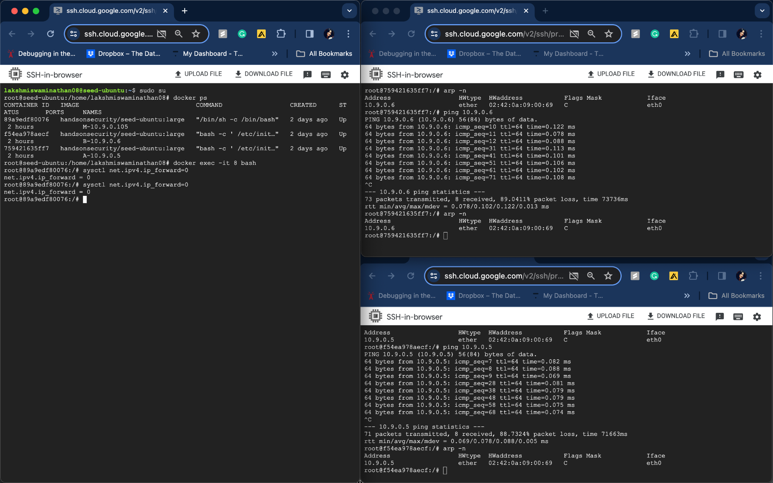

**Below are the results from wireshark with IP forwarding turned on(sysctl net.ipv4.ip_forward=0) in host M:**

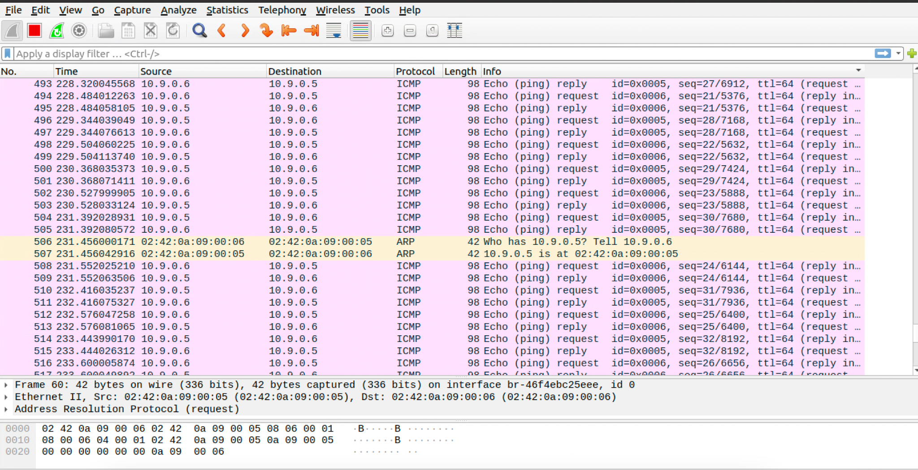

**Step 3:** **Pinging host A to B and host B to A when the ARP cache is poisoned for host A and host B with IP forwarding turned on(sysctl net.ipv4.ip_forward=1) in host M.**

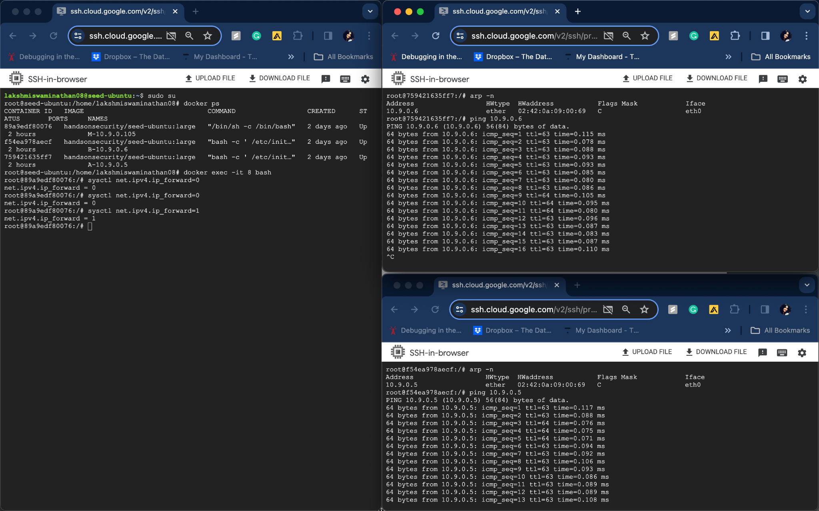

**Below are the results from wireshark with IP forwarding turned on(sysctl net.ipv4.ip_forward=1) in host M:**

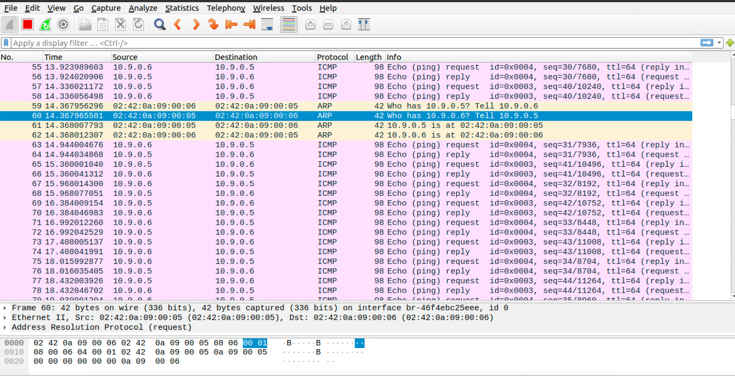

**Step 4 (Launch the MITM attack) on Telnet using ARP cache poisoning**

**Code:** Sniffing and spoofing(to All z’s) tcp packets from A’s MAC address or B’s MAC address on telnet

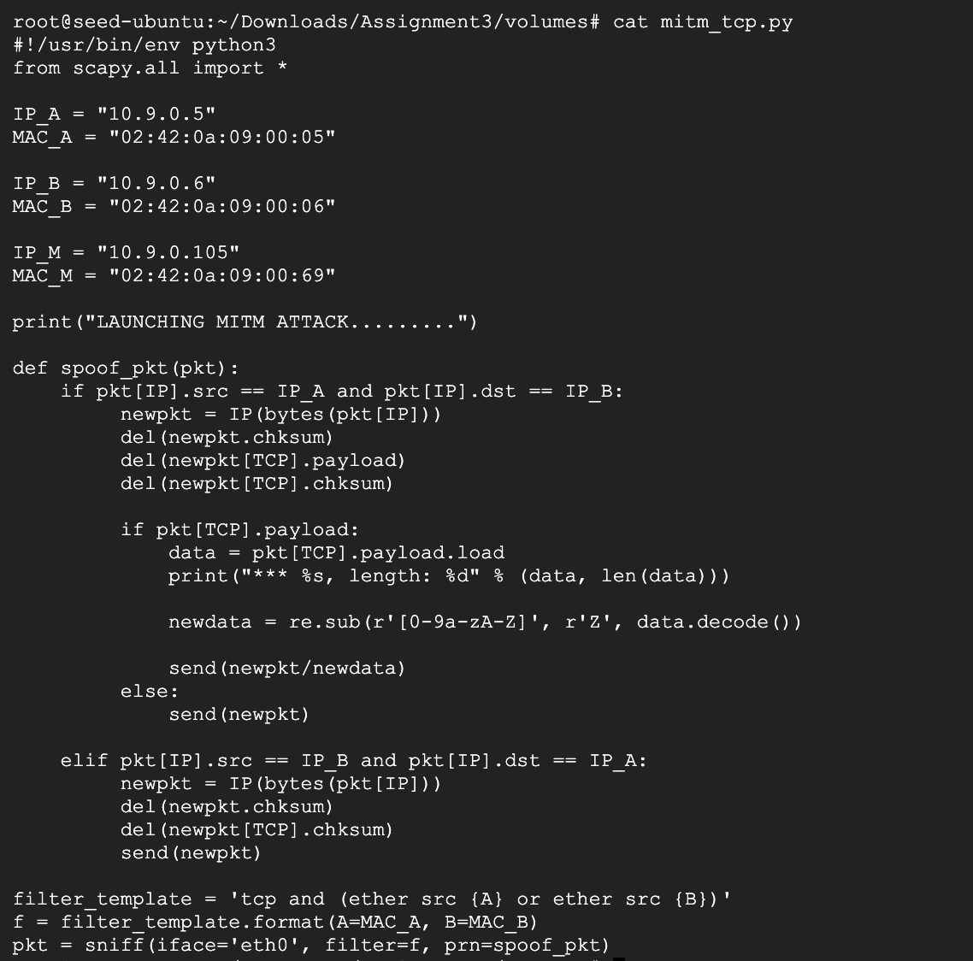

**Below is the result of execution of MITM attack on Telnet using ARP cache poisoning**

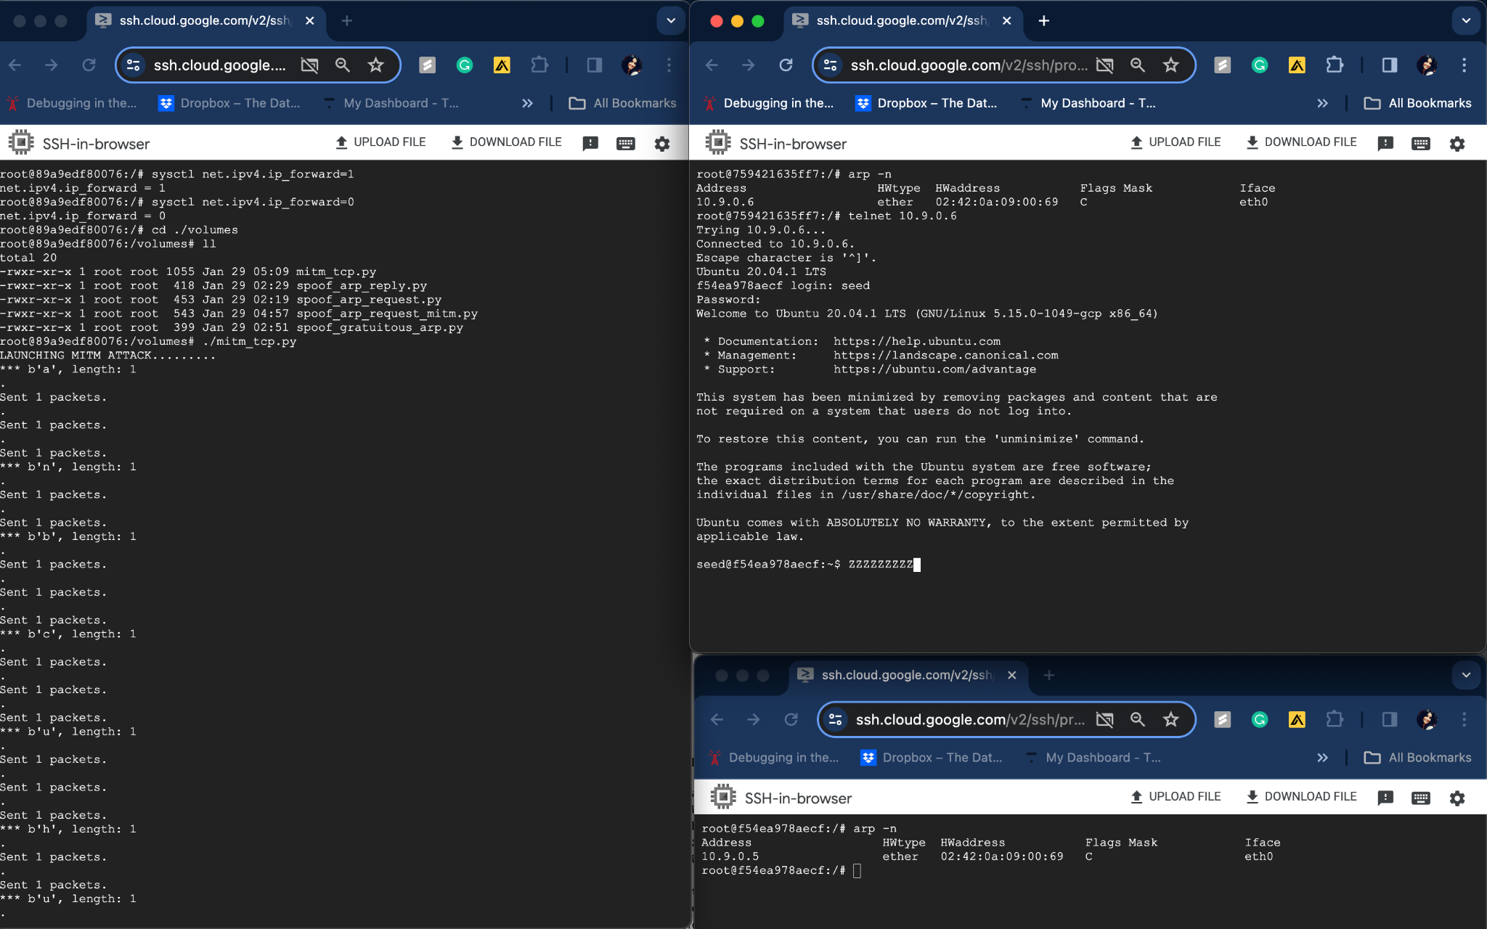

The IP forwarding was turned on in host M to establish telnet connection once the connection is established, the IP forwarding is tuned off and the MITM attack code to sniff and spoof the telnet connection content to Z’s in real-time. (establishing telnet connection from host A to host B(Host B is telnet server)

**Task 3: MITM Attack on Netcat using ARP Cache Poisoning**

**Code:**

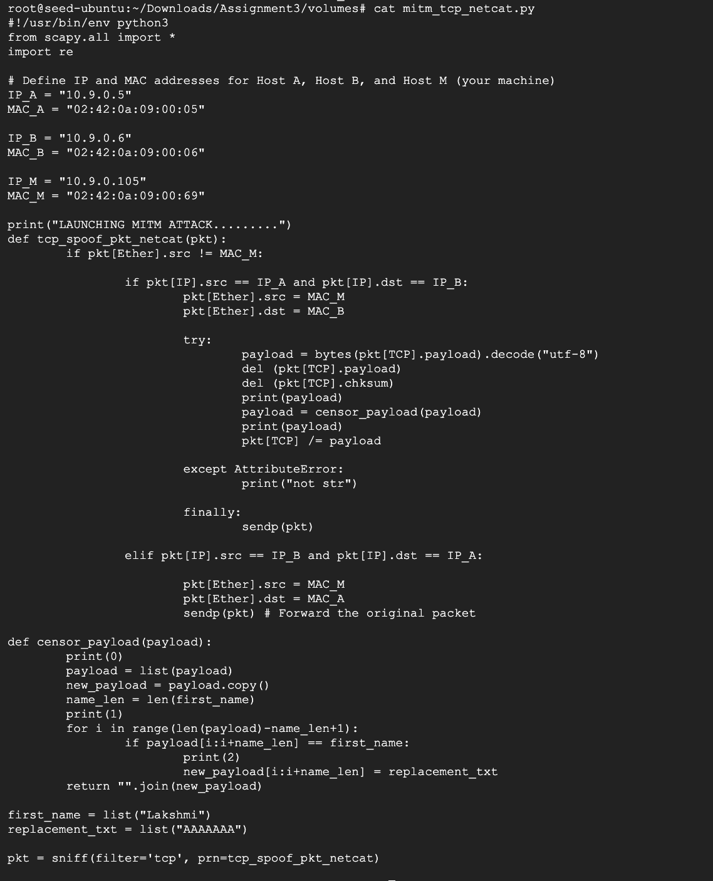

Below is the result of execution of MITM using ARP cache poisoning on Netcat: As mentioned in the task my first name(Lakshmi) is changed to all A’s in the tcp server(nc -lp 9090 - listener - Host B)

